**BMA Scottish GP Committee/Scottish LMC Update – October 2020**

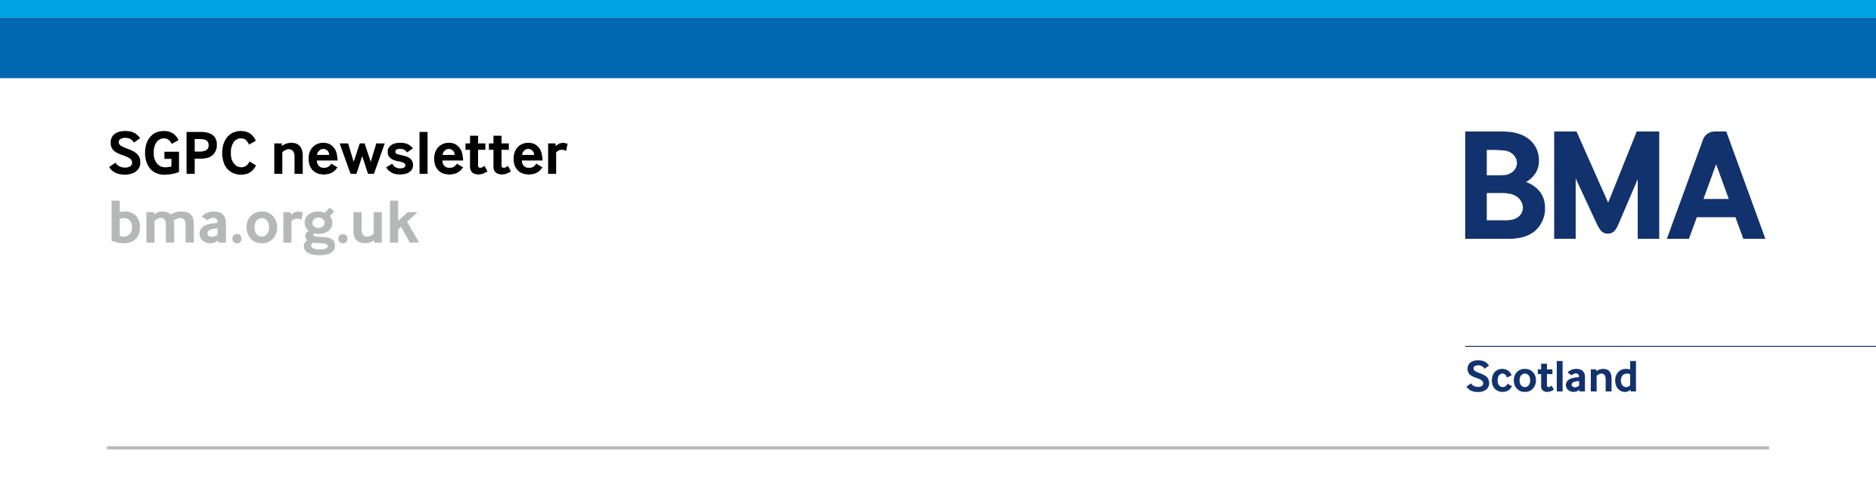

# BMA Scottish GP Committee (SGPC) Update:

## BMA SGPC Meeting – 22 October 2020

### BMA SGPC Meeting – 22 October 2020

The BMA Scottish GP Committee (SGPC) held its first meeting of session on 22 October 2020. Progress on delivery of the 2018 GMS contract was discussed along with work to negotiate transitionary arrangements following the end of the implementation period. The committee discussed recovery and remobilisation with a focus on general practice priorities, urgent care and enhanced COVID-19 pathway proposals, and GP IT issues, and received reports from various GPC meetings, external groups, and the GP Sessional Committee.

SGPC also heard updates on letters produced by Scottish Government including the Primary Care Improvement Fund letter, and an update on NHSScotland Primary Care National Premises meeting, GP Wellbeing, and the SLMC Conference on 4 December. A pensions update was provided by Dr Alan Robertson, a member of the BMA Pensions Committee who was leading on a lot of the work.

The results of the election of office bearers was announced at the meeting with Dr Andrew Cowie and Dr Patricia Moultrie elected uncontested as joint deputy chairs. Dr Chris Black, Dr Iain Kennedy, Dr John Ip, Dr Denise Mcfarlane and Dr Tyra Smyth were successfully elected on to SGPC Executive for session 2020-21.

## COVID-19 Recovery and Remobilisation

### COVID-19 Funding

The BMA Scottish GP Committee is in negotiation with Scottish Government regarding arrangements for funding during the second wave of COVID-19 and is seeking arrangements similar to those back in March 2020 including arrangements for recruitment of locum GPs in the case of self-isolation and sickness leave that do not require pre-approval from boards, availability of sickness cover from day 1, and the ability to claim funding again for non-staff costs.

### Urgent Care/ Enhanced COVID-19 Pathway Proposals

The BMA Scottish GP Committee (SGPC) has been involved in various COVID-19 remobilisation meetings, which have included discussion of the reform of urgent care and the need to support an enhanced COVID-19 pathway in the months ahead. The chairs of SGPC, the RCGP and the Primary Care Leads group wrote jointly to the cabinet secretary on 13 August to express significant concerns with the redesign of urgent care and proposed national programme of work to manage the unscheduled work of Emergency Departments through triage flow hubs.

## Negotiating issues and contracts

### BMA Scottish GP Committee / Scottish Government Negotiations on MoU and 2018 GMS Contract

The BMA Scottish GP Committee has held several meetings with the Scottish Government to reflect on the level of progress of contract implementation and the need for transition arrangements to be put in place from April 2021.

The Memorandum of Understanding priorities have been discussed in more detail with Scottish Government colleagues and initial work has begun on describing transitionary arrangements for the 6 MoU priorities: Vaccination Transformation Programme (VTP), Pharmacotherapy services, Community Treatment and Care Services (CTACS), Urgent Care (Advanced Practitioners), Additional Professional Roles (including community mental health professionals, and musculoskeletal physiotherapists, and Community Link Workers (CLW).

### Transformation of Primary Care

Primary Care Improvement Plan and Workforce Tracker submissions were due on 16 October 2020. The Scottish Government and BMA Scottish GP Committee will be reviewing these in due course along with the National GMS Oversight Group which is due to meet on 10 December 2020.

### Influenza Vaccinations

Agreement has been reached with Scottish Government on national arrangements that will protect the income that practices would normally receive from influenza vaccination activity in exchange for providing a similar time commitment as in previous years. Health boards will have primary responsibility for the programme and will be required to meet vaccination demand beyond that practice contribution. Alternative local arrangements have been agreed in a number of areas which remain in place, with the national agreement acting as a backstop for where local agreement has not been reached.

## Information Management and Technology

### Scottish Joint GP IT Group

The tenth meeting of the Scottish Joint GP IT Group will be held virtually on 11 November 2020, with an update on Digital Asynchronous Consulting systems, GP IT Re-Provisioning, primary care GP IT infrastructure.

SJGPITG also heard updates from the Primary Care Reform Digital Board, NHS Education for Scotland -National Digital Services (NDS), Scottish National Users Group (SNUG), Systematised Nomenclature of Medicine – Clinical Terms (SNOMED-CT), Scottish Clinical Information Management in Practice (SCIMP), Emergency Care Summary (ECS) Service Board, and GP2GP. In addition, there was discussion on child surveillance registers, GP IT for locums, electronic solutions to subject access requests. Other topics discussed include data repository, electronic prescribing and order comms. The next meeting of the group will likely be held virtually in February 2021. Details of dates will be sent to the group for confirmation.

# LMC Update:

## For information

### Scottish LMC Conference

The Scottish Local Medical Committee Conference will be held virtually via MS Teams this year on 4 December 2020 with keynote speech from the cabinet secretary for health and sport, Ms Jeane Freeman MSP, and motions on wellbeing/workforce, public health, immunisations, contract and negotiations and much more.

### LMC and GP Subcommittee Board Visits

Due to the impact of COVID-19 the negotiating team have postponed all physical future visits. The negotiating team are however attending virtual meetings. If it would be helpful to meet with the negotiating team virtually please do get in touch.

## Contact us and follow our work

### Our BMA Scottish GP Committee (SGPC) negotiating Team:

|  |  |  |  |  |  |  |
| --- | --- | --- | --- | --- | --- | --- |
| |  |  |  | | --- | --- | --- | |  |  | C:\Users\patricia\Pictures\.jpg | | ***Dr Andrew Cowie***  ***Deputy Chair, SGPC*** | ***Dr Andrew Buist***  ***Chair, SGPC*** | ***Dr Patricia Moultrie***  ***Deputy Chair, SGPC*** |   **Any emails for the** **BMA Scottish GP Committee negotiating team should be submitted to** [info.gpscotland@bma.org.uk](mailto:info.gpscotland@bma.org.uk) **Your ideas about achievable measures to reduce pressure on general practice are always welcome.  We can’t respond to every email, but all emails are read and considered by the team.** |

### Blogs from our negotiating team:

* [COVID-19, Winter and General Practice](https://bmascotland.home.blog/2020/10/15/covid19-winter-and-general-practice/) – 15 October 2020
* [How COVID has helped GPs Find A Different Way of Working](https://bmascotland.home.blog/2020/09/17/how-covid-has-helped-gps-find-a-different-way-of-working/) – 17 September 2020

### Follow the work of the BMA online:

|  |  |
| --- | --- |
| Blog:  <https://bmascotland.home.blog/> | [cid:image002.jpg@01D51089.B3F46540](https://twitter.com/BMAScotland)Twitter: [**@BMAScotland**](https://twitter.com/BMAScotland)  <https://twitter.com/BMAScotland> |
| [cid:image001.jpg@01D51089.B3F46540](https://www.facebook.com/bmascotland)Facebook: <https://www.facebook.com/bmascotland> | [cid:image003.jpg@01D51089.B3F46540](https://www.instagram.com/bmascotland)Instagram:  <https://www.instagram.com/bmascotland> |

**LMCs are reminded they can contact Andrea Ma, BMA Scottish GP Committee (SGPC) secretariat for more details (**[ama@bma.org.uk](mailto:ama@bma.org.uk)**).**